Summertown Group Practice
Patient Participation Meeting
5 September 2024
12.30 – 13.30
North Oxford Association – Library

- Practice staff changes

-In August, Dr Joseph Doris and Dr Emily McGhee took up salaried GP positions at the practice following their GP training with us. Increasing the total number of GP sessions by six per week.
-In August three new registrars commenced their placements with the practice,
Dr Alexandra Choa and Dr Isabella De Vere Hunt will be with us for two years and Dr Susannah Black will be with us for a year.
-In July a new PCN Mental Health worker started at the practice. Cecilia Osei Gyeni will be working with us on a Monday and a Wednesday.
-In August we recently employed two new patient service coordinators Lousie Stedman and Madeleine Jeapes, increasing our reception hours, particularly first thing in the morning.

Discussion was also had regarding new GP Assistant role at the practice. This role assists our GP’s with some of their administration work, such as helping with insurance report and safeguarding administration as well has being able to put on additional ECG and phlebotomy appointment when needed.
- New building update

The Buckinghamshire, Oxfordshire and Berkshire West Integrated Care Board (BOB ICB) have currently advised that our PID for the South Parade development has currently not been approved. Funding is currently being utilised for deprivation areas, but we are on the list for further reviews. We will be having another catch up meeting with them in due course to see if anything has change or materialised since we last spoke. Heidi to keep the PPG members updated if there is any change.

- Covid/flu/RSV campaigns

As a practice we will be staring our covid/flu clinics on Saturday 5th October, with other clinics scheduled for Saturday 12th and Saturday 19th October. We are hoping to add some additional clinics in November.
We will also be holding a clinic for the RSV vaccine for over 65’s and pregnant patients 28 weeks + we will also be running a child flu (2-3years) on Saturday 14th September.

We would be keen to have volunteers to help with the marshalling of these clinic as they can get very busy. Please email Scarlett if you would like to help.

We have had a massive uptake on our clinics already with over 1000 patients booked in.

- IT update – Patient access, NHS App

We are looking to set up a drop-in clinic for patients needing help using the NHS app or setting the app up. Dates to be confirmed.

Question was raised regarding how to use the NHS app on your desktop. We can confirm this is possible, please see the link below for further information.

You can use the NHS app on your desktop, please see the link below.
How to use the NHS App from a web browser – NHS Digital Support Centre (zendesk.com)

We will shortly be making more appointments online bookable via the NHS App, currently this can only be done for Covid/Flu/RSV vaccinations and telephone calls. We will be opening up the bookable appointments for long term conditions, smears and blood tests requested by GP. This will allow us still to have routine appointments available for when people call into the surgery.

- Research update

Our practices have 4 new studies called ECRIAD, ATHENA, COAT and TIGER which our duty doctors will be help recruit patients for. They would need to fit a criteria for us to be able to refer our patients to one of the studies we are currently offering. We have also added a few of our studies that we are participating in on Facebook.

- Pharmacy First

The practice and the local pharamcies are now using the Pharmacy First Scheme, we are currently working closely with Medipill in Summertown on this. Reception are able to refer patients directly to the pharmacy with the consent of the patient for the following seven conditions.
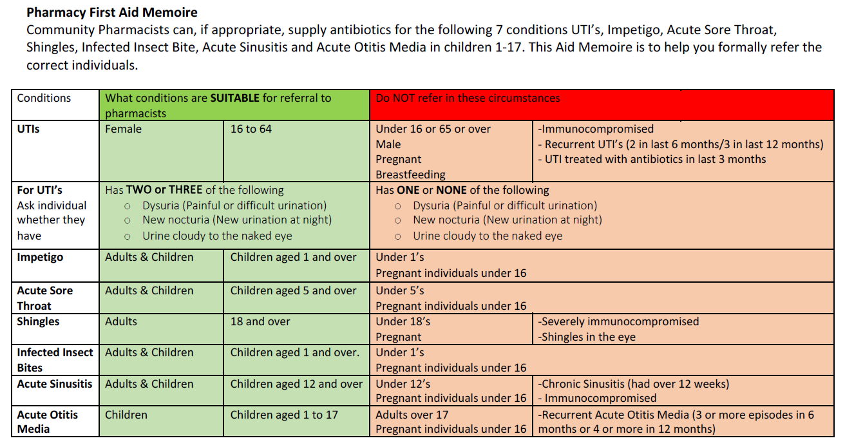

- Feedback

Our recent practice survey was discussed. The partners, Heidi and Gemma are currently reviewing the results to see where improvements can be made. Please see link below to view survey results

GP Patient Survey (gp-patient.co.uk)

We will also be conducting surveys in our waiting rooms based on these questions to ensure that we get a wider range of feedback due to the low level of responses. Scarlett will also be sending a questionnaire out to our PPG members.

The practice will also be re-introducing the feedback boxes in waiting rooms, as per Chris’s previous suggestion.

Feedback from PPG
- A few members would like one of the doctors to come to our PPG meetings. Dr Monach was due to attend.
- Clearer communication needed for patients regarding what happens following blood tests. Nurses to be reminded to inform patients that if results are normal, they will not receive a call from the practice. Poster to be put up in waiting room for patient information as well.
- Poster to also be put up on notice boards regarding prescription wait times.
- Mixed feedback received regarding Facebook posts. Practice will continue to inform patients of important notices and increase number health promotions. Chris mentioned that a volunteer could help with this. Gemma and Heidi to take back to partners.
- Sam gave positive feedback about our reception staff.
- More information needed on our e-consult service, in particular how this can be used for prescription queries. Scarlett to look at.

4.1115 Google reviews

